- Change this UI, it is not looking good. Drop the numbers and description should be more friendly but SHORT one two word. Remove this line –“ A few simple steps….college demo. Replace with some short professional User friendly line, don’t mention demo”
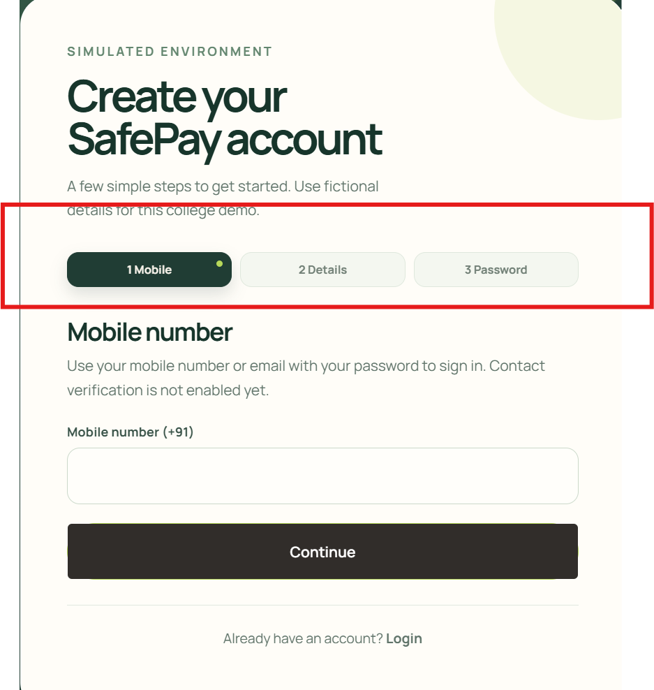

- Change footer. Make it professional, with some interesting tag line for SafePay. Change the Diamond symbol(present beside safe pay). Footer alignment should be profession looking as in the given sample and should be present and with same design and consistency in every page.
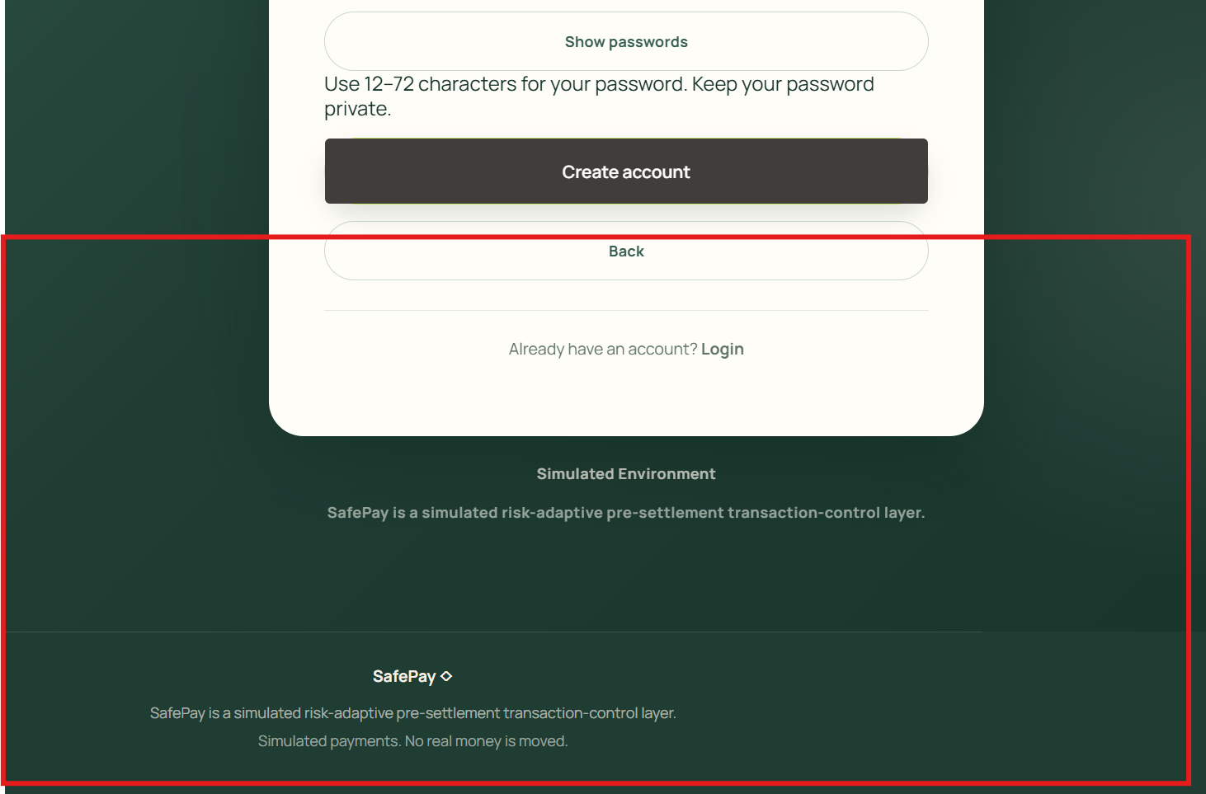
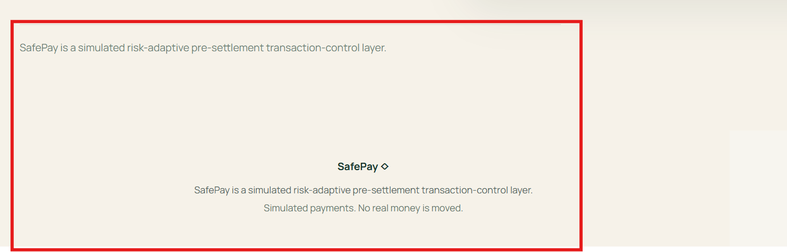

Take inspiration for footer design from below -
Just put placeholders for social (twitter and insta only for now , unclickable or not with hyperlink).
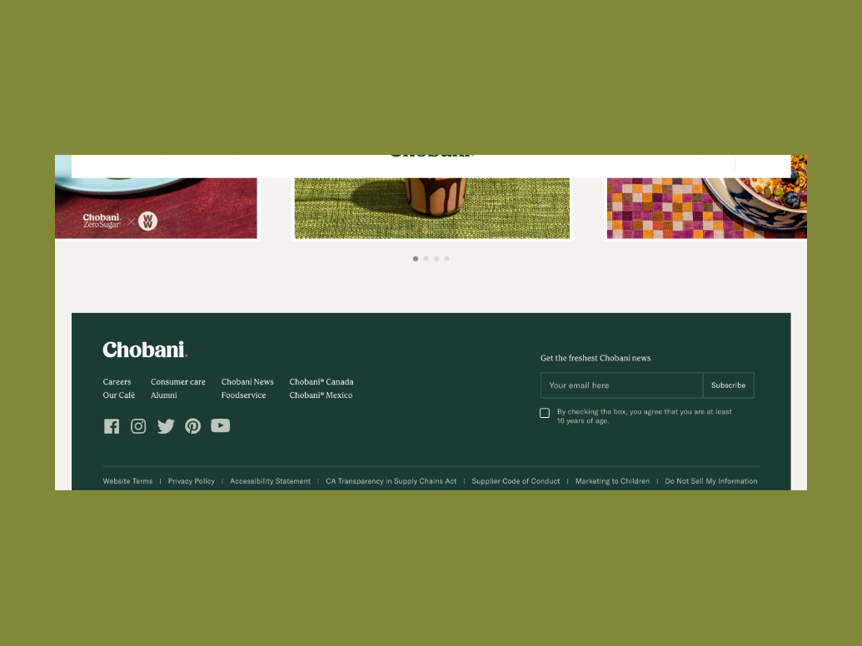

- Below post account creation page does not look that good. Give a good logo for safepay. The user has to scroll down to see the full card , not just in this page but every page. But don’t try to fit in eveyrtime or compact or decrease font in every such login/create account pages. Try to incorporate User friendliness with easy viewing but don’t break the UI too much.
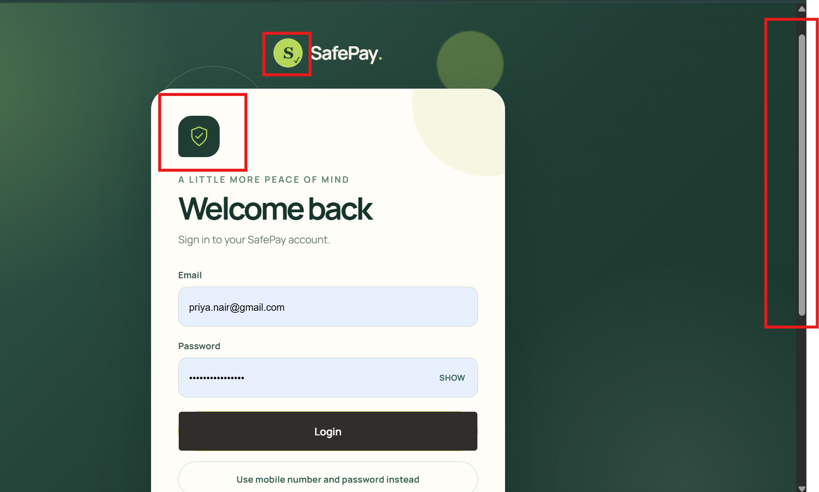

Use the logo given at "C:\Users\Aditya Rao\Downloads\Training\Project\SafePay\safepay-logo.png". And keep it’s Rupee+S symbol wherever appropriate and consistent throughout the application pages.
Don’t change this below animation though, which loads when home page(landing page is loaded)


- This below image/page/logo is getting loaded in every refresh. The above logo , that you will be designing and creating.
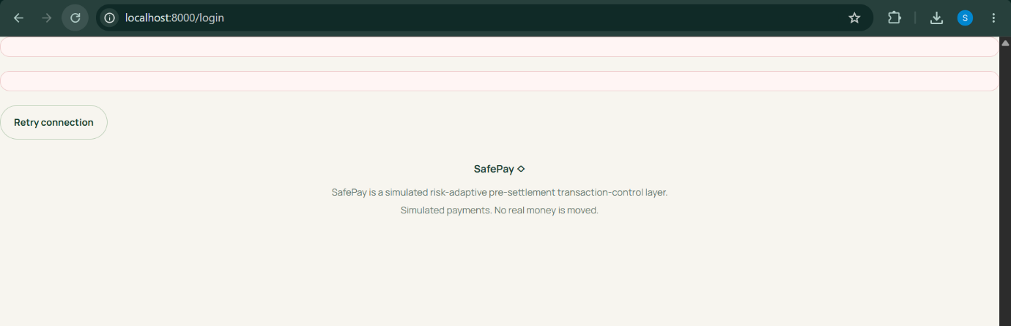
Instead this below animation (which is already present when the home page loads) should be played (for 2 secs) with rupee symbol revolving in a fixed axis(where it is present currently) .



